Project 1
War Card Game

CSC-17A
Section 42448
Michael Risher
April 30, 2014
I. Introduction:

Title: War Card Game

The goal of this program is be able to play a game of war with a computer. The game of war is simple. You split the deck between the players and then deal a card one at a time. The highest card wins.

II. Summary

Project lines of code: 853

This Program is a card game called war. The game is player with two or more players. The deck is split between the players and the players then deal out one card at a time and the highest card dealt wins. The objective is to have all the cards by the end of the game. In this version of the game one through king have their face value and ace defeat all cards below king. If the user choice to allow jokers as an all powerful card then there are two jokers in the deck that beat all lesser cards.

III. Instructions:

The program will start by asking if you can see the card suit symbols correctly, since netbean's internal console can not print out symbols like windows terminal.
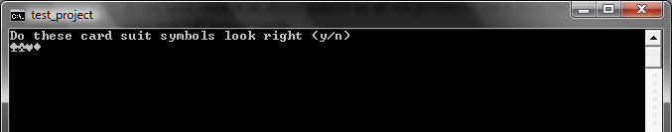
Then it will ask if you would like to include jokers as all powerful cards.
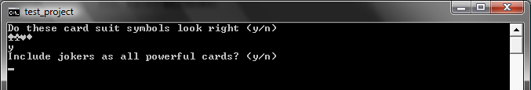
When you have finished answering that the game will then tell you to press enter to deal your card.
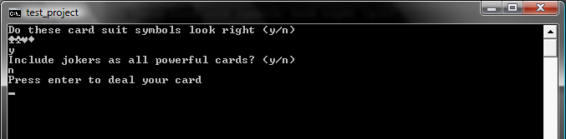
Then from here you keep dealing your cards until some one wins. It will show you the cards you drew and the number of cards you now hold.
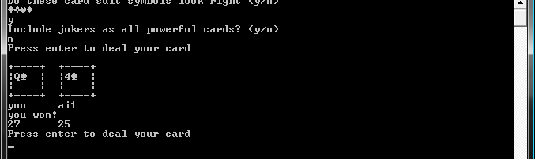
When a player finally wins it will ask you if you want to play again you can answer this with a y or n though its not shown in the picture
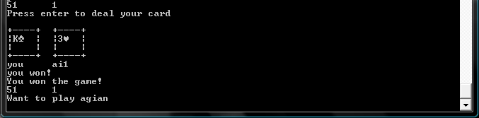

IV. Pseudocode:

Start

start main loop
ask for users input on reading Unicode symbols

ask user if jokers should be used
verify input should only be n or y

make the deck and shuffle it 10 times
deal the cards to the players
start the game loop
print out the players 1st card
check to see who won
print out who won
check if the game is over
if game is over
print the winner
exit game loop
if game is not over
make a copy of the players decks and move the card they just played
to the bottom of their deck and take the losers card that they played
print out the deck sizes for all players
goto game loop
ask if user wants to play again
if want to play again
goto main loop
else
exit

V. Flowchart:

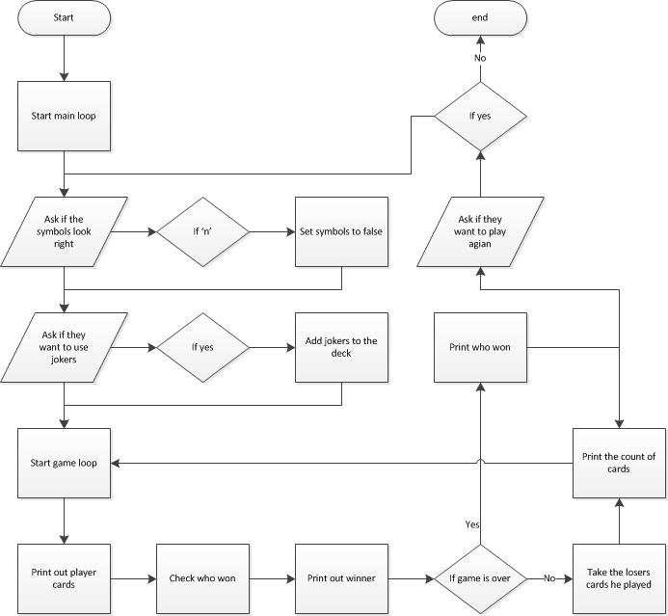

VI. Notes:

- The flowcharts are attached inside the project zip.

